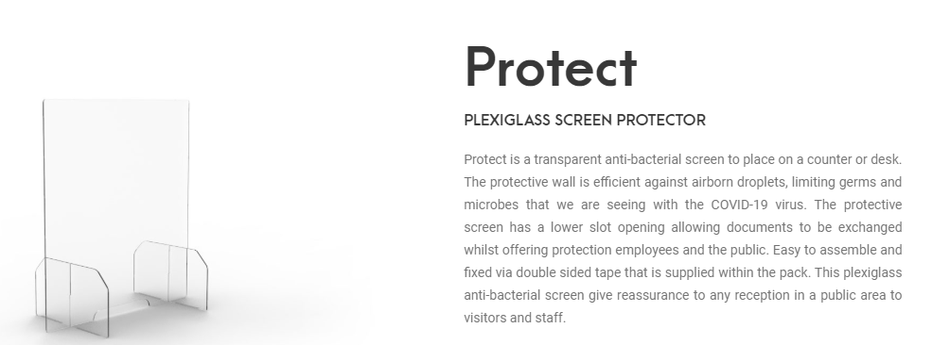
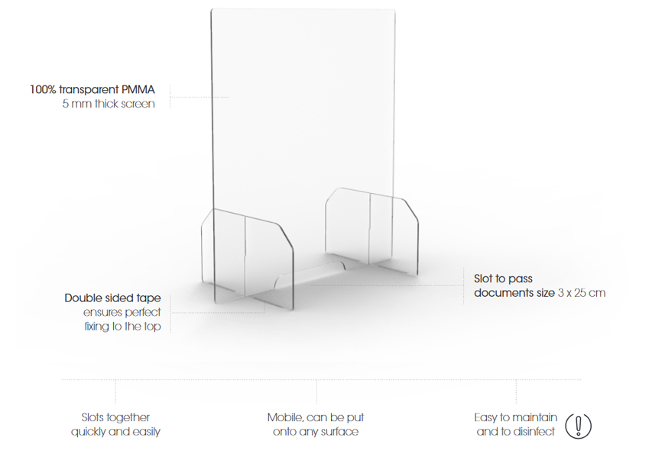

Reference Lyreco : 12.831.434 /PK5 63X70CMX5mm : €455

